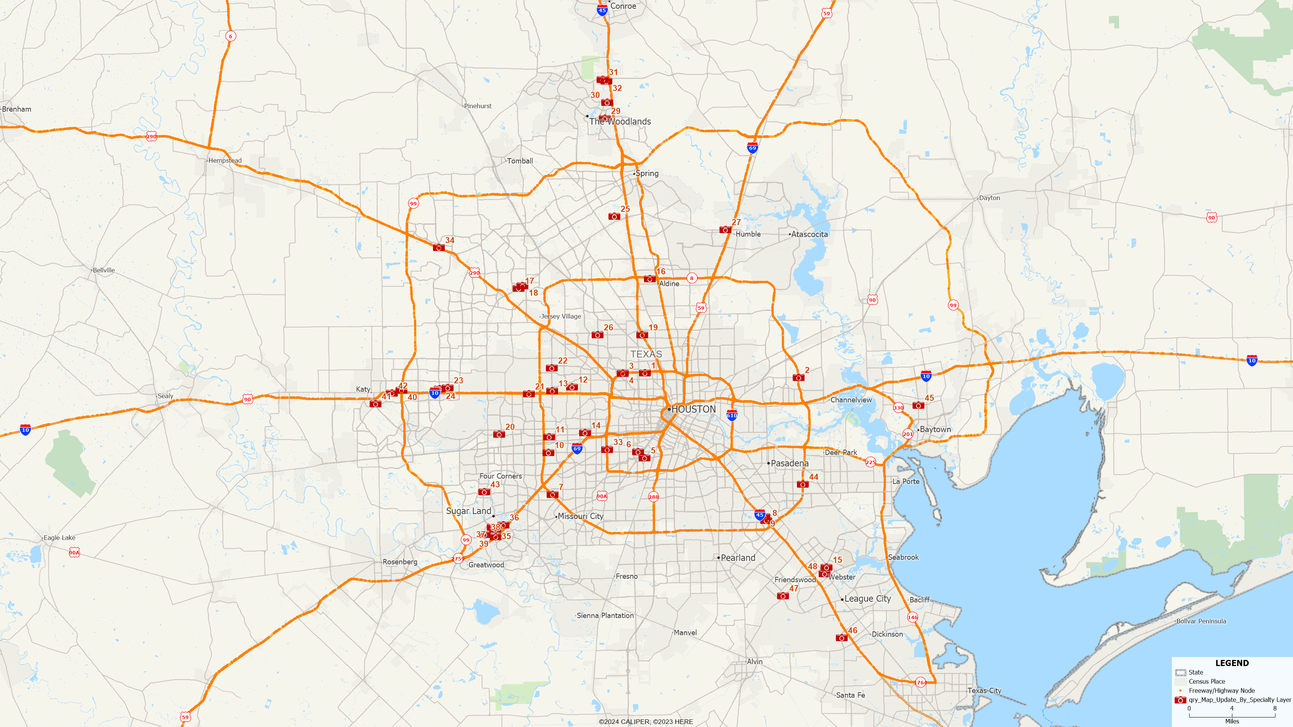

No | Name | Address | City | State | Zip
1 | North Houston Imaging Center | 237 North Loop West | Houston | TX | 77008
2 | Houston MRI & Diagnostic Imaging | 5630 East Sam Houston Pkwy North | Houston | TX | 77015
3 | Memorial MRI & Diagnostic Imaging Centers | 1900 North Loop W. STE 160 | Houston | TX | 77018
4 | Solis Mammography Houston North Loop West | 1900 North Loop West, STE. 350 | Houston | TX | 77018

No | Name | Address | City | State | Zip
5 | One Step Diagnostic II, Inc. | 7227 Fannin St., Ste 102 | Houston | TX | 77030
6 | SimonMed Imaging-Med Center | 2256 W Holcombe Blvd | Houston | TX | 77030
7 | SimonMed Imaging-Beltway | 11375 S. Sam Houston Pkwy W., STE 150 | Houston | TX | 77031
8 | Houston Premier Radiology Center | 12853 Gulf Freeway | Houston | TX | 77034
9 | The Rose SE | 12700 N. Featherwood, Ste. 260 | Houston | TX | 77034
10 | Bellaire Diagnostic Imaging | 9440 Bellaire Blvd STE 100 | Houston | TX | 77036
11 | Ultrasound Associates USA LLC | 3535 Briarpark Drive Suite 101 | Houston | Tx | 77042
12 | Memorial MRI & Diagnostic | 1346 Campbell Rd | Houston | TX | 77055
13 | Woodlake Imaging LLC | 1065 Gessner Rd STE 100 | Houston | TX | 77055
14 | Advantis MRI & Imaging | 6300 Richmond Ave, STE 104 | Houston | TX | 77057
15 | Gulf Coast MRI and Diagnostic | 830 Gemini Ave | Houston | TX | 77058
16 | Houston Neurodiagnostics | 507 N Sam Houston Parkway East. STE 292 | Houston | TX | 77060
17 | Fallbrook Open MRI | 11770 FM 1960 Rd. West | Houston | TX | 77065
18 | Solis Mammography Cy-Fair | 11307 FM 1960 Rd. W., STE. 340 | Houston | TX | 77065
19 | Unicare MRI & Diagnostic Center, LLC | 7007 North FRWY STE 110 | Houston | TX | 77076
20 | Westchase Diagnostic Imaging Center | 13450 Richmond Ave. STE 300 | Houston | TX | 77077
21 | One Step Diagnostic IX LP | 11211 Katy Fwy., Ste. 201 | Houston | TX | 77079
22 | Houston MRI & Diagnostic Imaging | 2600 N Gessner Rd, Suite 150 | Houston | TX | 77080
23 | Katy Open MRI | 2051 Greenhouse Rd., Ste. 100 | Houston | TX | 77084
24 | Memorial MRI & Diagnostic | 1718 North Fry Rd | Houston | TX | 77084
25 | One Step Diagnostic, Inc. | 17320 Red Oak Dr., Ste. 100 | Houston | TX | 77090
26 | North Houston X-Ray & Imaging Ctr |  | Houston | TX | 77091
27 | Go-Imaging | 9802 FM 1960 Bypass W., Ste. 100 | Humble | TX | 77338
28 | Solis Mammography Montgomery | 20042 Eva Street, STE. 104 | Montgomery | TX | 77356
29 | Houston MRI & Diagnostic Imaging | 1733 Woodstead Court STE 100 | The Woodlands | TX | 77380
30 | SimonMed Imaging-The Woodlands | 8850 Six Pines Drive #190 | Shenandoah | TX | 77380
31 | One Step Diagnostic XI LP | 3117 College Park Dr., Ste. 100 | Conroe | TX | 77384
32 | River Oaks MRI & Diagnostic LLC | 17191 St. Lukes Way, Ste. 110 | The Woodlands | TX | 77384
33 | The Rose Galleria | 6575 West Loop South, Ste. 275 | Bellaire | TX | 77401
34 | Houston MRI & Diagnostic Imaging | 27126 Northwest Fwy., Ste. 200 | Cypress | TX | 77433
35 | Global Imaging, LLP | 1435 Highway 6 STE 102 | Sugarland | TX | 77478
36 | Houston MRI & Diagnostic Imaging | 15555 Creek Bend Dr STE 300 | Sugarland | TX | 77478

No | Name | Address | City | State | Zip
37 | Solis Mammography Sugar Land | 1111 Highway 6 South, STE. 260 | Sugar Land | TX | 77478
38 | AV Imaging, PLLC | 12920 University Blvd., Ste. 600 | Sugar land | TX | 77479
39 | SimonMed Imaging-First Colony | 16550 Southwest Freeway, Ste C | Sugar Land | TX | 77479
40 | Solis Mammography Katy | 1331 W Grand Parkway North, STE. 240 | Katy | TX | 77493
41 | Houston MRI & Diagnostic Imaging | 1336 Pin Oak Road | Katy | TX | 77494
42 | SimonMed Imaging-Katy | 24600 Katy Freeway | Katy | Tx | 77494
43 | Memorial MRI & Diagnostic | 11211 S Highway 6, STE B | Sugar Land | TX | 77498
44 | Gulf Coast MRI and Diagnostic | 3692 E. Sam Houston Pkwy S STE 200 | Pasadena | TX | 77505
45 | Universal MRI Baytown | 4310 Garth Road, Ste. A | Baytown | TX | 77521
46 | One Step Diagnostic VIII LP | 2401 FM 646 Rd. West, Ste. B | Dickinson | TX | 77539
47 | Houston MRI & Diagnostic Imaging | 1505 Winding Way Drive, Suite 110 | Friendswood | Tx | 77546
48 | Lakeside MRI & Diagnostic Center | 17360 Highway 3 | Webster | TX | 77598

